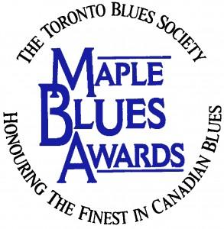

Media Accreditation Request
Maple Blues Awards
January 18th, 2016

Please complete this form and submit by attaching it to an email by January 8th, 2016

All fields must be filled out to process accreditation request.

Media Outlet:
Contact Name:
Phone:
Email:
Website:
Social Media Links:

Media Format:
Broadcast ☐ Print ☐ Online ☐ Photographer ☐

How do you plan to promote the awards?

Nominee or Performer Interview Requests
* subject to artist availability

Notes and Policies
- We have a limited number of media passes / photographer positions and cannot guarantee that everyone will receive accreditation.

- Applicants will be notified by January 12th, 2016.

- Media Accreditation does not grant access to backstage or green room areas.

Toronto Blues Society / Maple Blues Awards Social Media Links
Facebook: https://www.facebook.com/TorontoBluesSociety
Twitter: https://twitter.com/TOBluesSociety
Hashtag: #MapleBlues

